How L293D Motor driver works
This is the simplest and small integrated circuit to drive up to four motors for chip.
ATTENTION: this guide doesn't explain in detail all the specifications of this chip, it just explains how to use it to drive motors.
First way to drive motors:
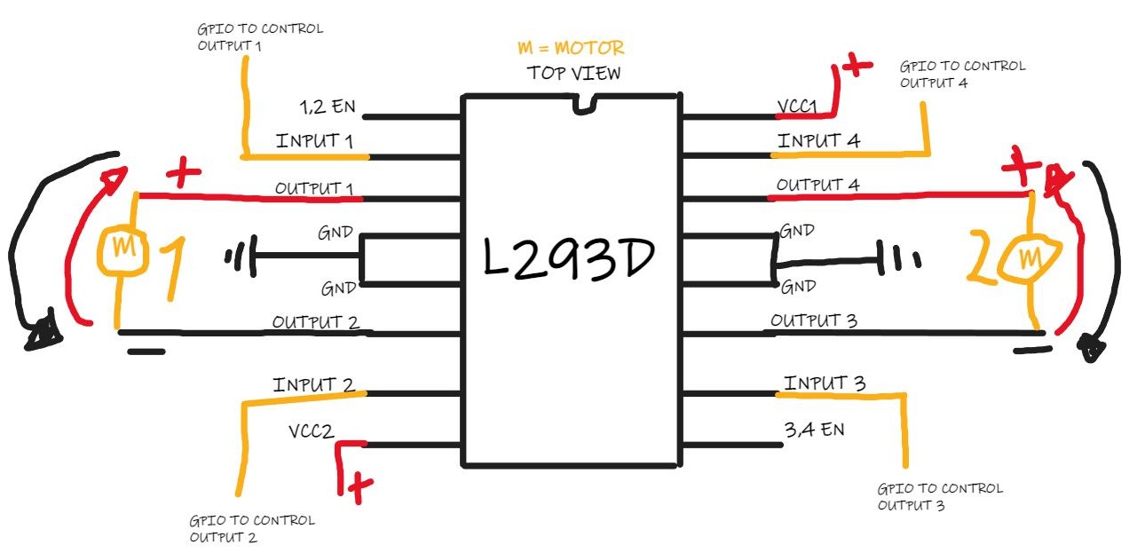
If you want to full control the direction (in the image, rapresented with the colored arrows) , you have to connect both cables (GND and VCC) of the motors, in two OUTPUT Pins of the L293D, and all of OUTPUT Pins (and therefore the direction) will be controlled with INPUT pins, connected with board's GPIO, like in the image above.

Second way to drive motors:
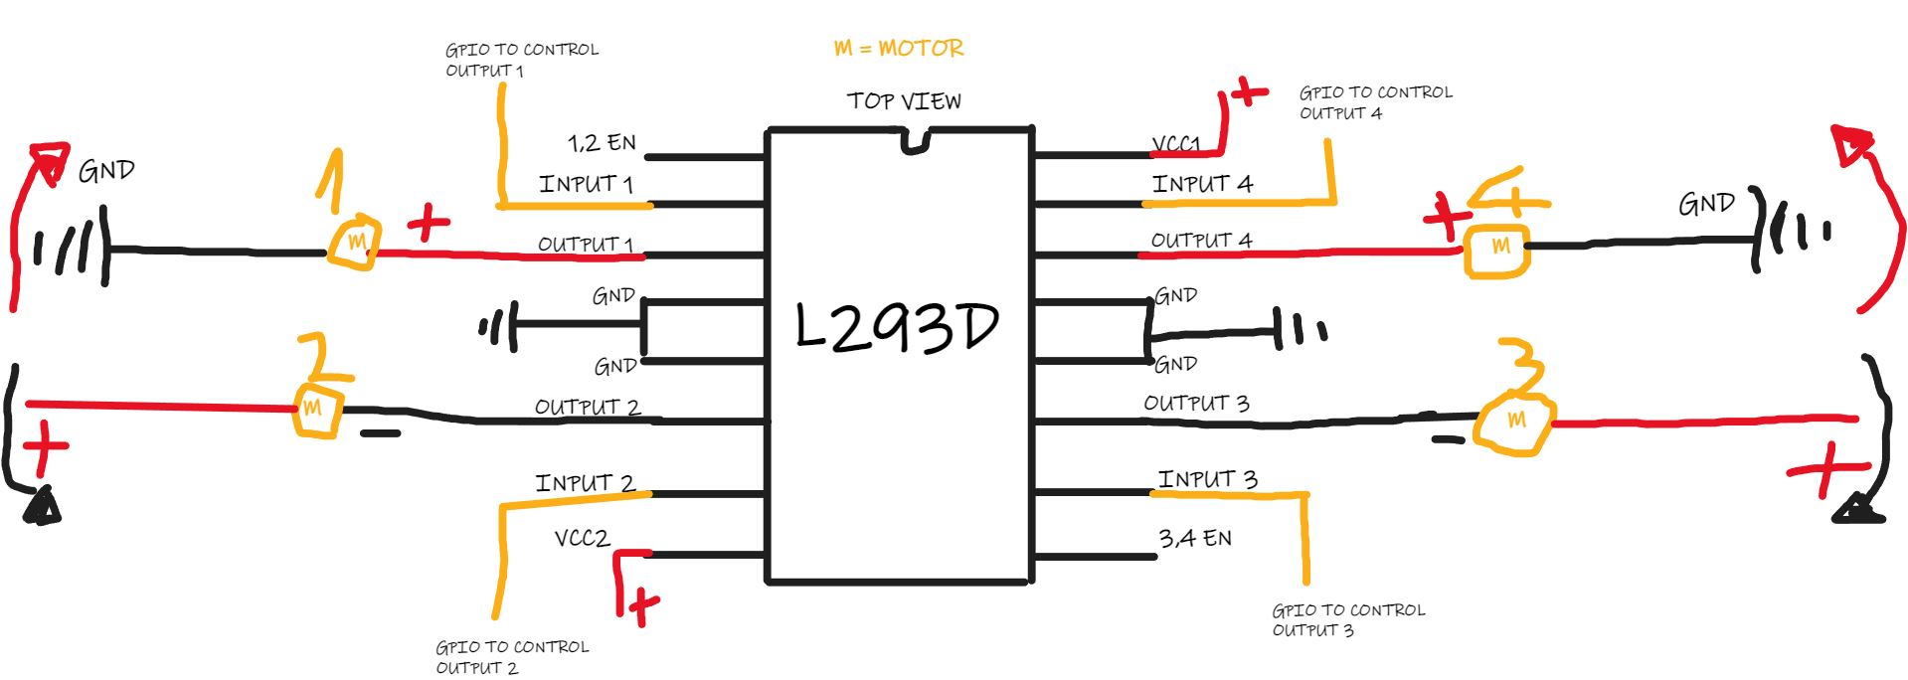
If you want to connect 4 motors you have to choose in which direction the motor will go. (in the image, the directions are rapresented with the colored arrows), You have to connect one of the cables (GND or VCC) of the motors, in one of the OUTPUT Pins of the L293D and the other cable in a common GND or in a common VCC. All of OUTPUT pins will be controlled with INPUT pins, connected with board's GPIO, like in the image above.

